**Summary of Neighborhood Area Planning Forum**

**June 12, 2018**

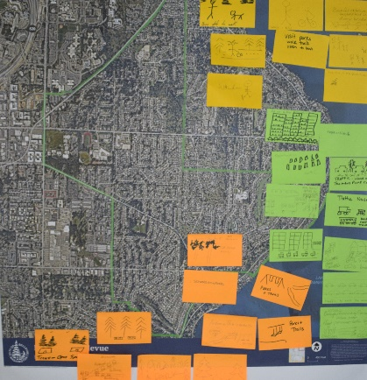

**Planning Services and Neighborhood Services hosted a community forum June 12, 2018,** at City Hall to discuss with residents the initial proposed plan for Neighborhood Area Planning. During the two-hour session, 39 residents wrote and illustrated on their Neighborhood Area Map the assets, distinctives and emerging issues in their neighborhoods. Residents offered their advice and questions on the proposed NAP process. They also shared their insight into engagement and inclusion within each of the 16 neighborhood areas. Staff will report the residents’ input and advice to council later this summer.

**Presentation**

*Neighborhood plans: depend on a collaborative relationship between the city and residents*

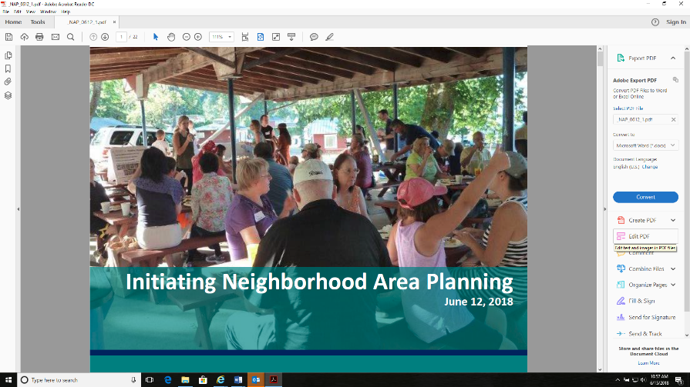Terry Cullen, Comprehensive Planning Manager and Deborah Munkberg, Senior Planner presented the initial proposal that was shared with council May 29, 2018. The presentation included an overview of area planning, the benefits of gathering information and hearing from residents in their own neighborhoods, the plan for inclusive outreach to individuals throughout the community, a brief proposed timeline, indicators that area planning has been successful and next steps in initiating Neighborhood Area Plans.

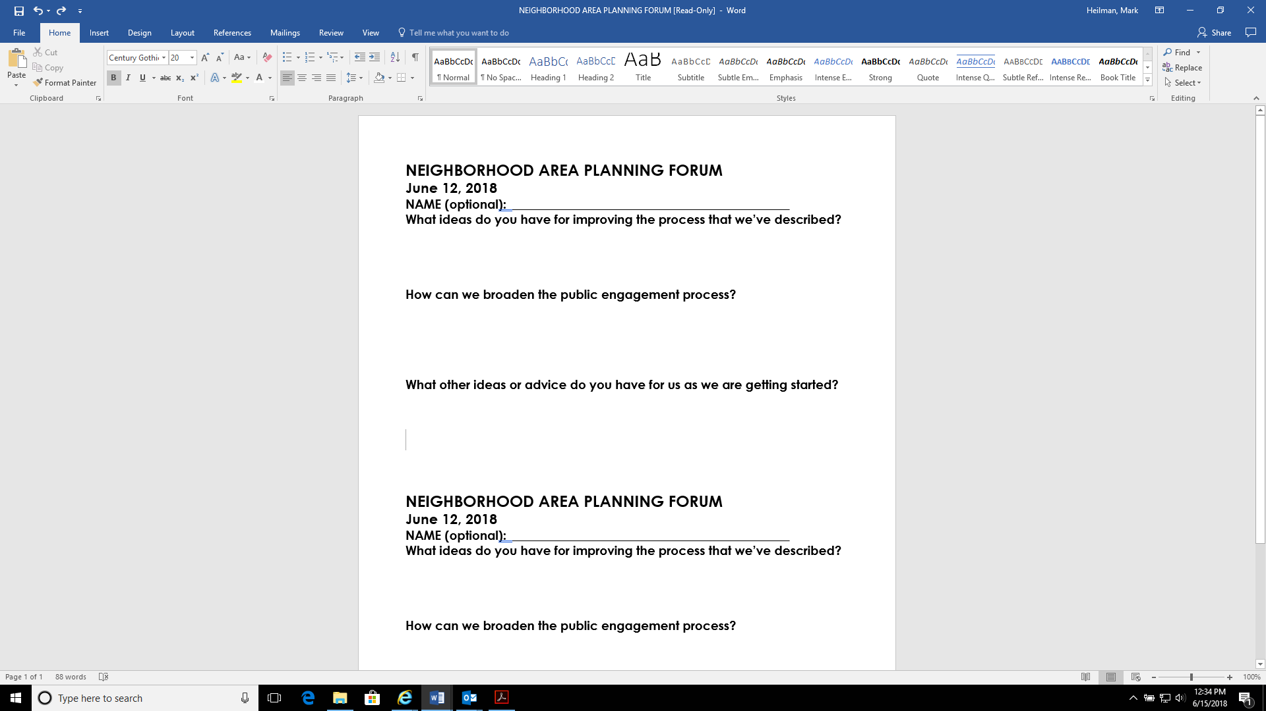**RESIDENT Questions and SuggeStions**

About one hour was provided to hear residents’ questions and suggestions. The responses were wide-ranging and helpful. Several questions focused on the scope of area plans and their relationship to previous plans and boundaries. Residents provided over 20 ideas for public engagement, including ideas on connecting with younger residents and incorporating the ideas of children and youth for Bellevue’s future.



**NEXT STEPS**

Terry Cullen and Deborah Munkberg informed residents of the next steps in the process, which include reporting residents’ input to council and asking council for guidance on how to proceed with initiating Neighborhood Area Planning. That report will be presented to council at the July 9, 2018 Council Study Session.

**Residents: Our Neighborhood’s Assets and Emerging Issues**

**Bridle Trails:**

What we love: “Horsey” areas, trees, size of yards with large lots, parks with miles of trails, natural

Emerging issues: power lines are eclipsing trees, tree cutting violations

**Cougar Mountain/Lakemont**:

What we love: birdwatching, Lewis Creek Park

Emerging issues: I’m a renter, will rent increase significantly?

**Crossroads:**

What we love: that it is still small, yards are gems, beautiful gardens, neighborly, diversity

Emerging issues: where is the effort to preserve large trees? Concern about lack of green space with increasing development. The questionable quality of the construction of new development – are developers building to last?

**Downtown:**

What we love: enjoy entertainment, vitality, walkability, downtown park

Emerging issues:  pedestrians and bike lanes

**Factoria:**

What we love:  proximity to the high school, hiking trails near Coal Creek

Concerns: traffic safety, for drivers and bikes

**Lake Hills:**

What we love: Larsen Lake, greenbelt, Robinswood Park, 148th Ave, city park and swings, walking with friends, diversity, public art

Emerging issues: traffic and density, street parking and no sidewalks, powerlines criss-crossing 148th Ave.

**Newport Hills/Lake Heights:**

What we love:the retail businesses, eagle’s nest, walking, biking, a friendly neighborhood

Emerging issues: traffic, housing density, development has it plusses and minuses, more parks needed in Bellevue

**Northeast Bellevue:**

What we love: biking, walking, visiting the parks, meeting our diverse neighbors while walking, 100+ year old trees, parks, trails and open space

Emerging issues:  traffic and access roads that lead to neighborhoods, encroachment of Redmond/Overlake

**Northwest Bellevue:**

What we love: Farmers’ Market, kayaking, walking, mid-century rambler houses, trees, community

Emerging issues: traffic is the biggest issue, trying to get out of our street; Lutheran Church new housing, walking in the neighborhood is difficult, car noise coming off the 520, straddling Bellevue Way, loss of tree canopy, loss of rambler houses being replaced with large 6,000-7,000 sq foot houses

**Somerset:**

What we love: That we can see all of the neighborhoods from our viewpoint, trees, greenspace to trails, unique houses with individual character, views at sunset, neighborhood pools

Emerging issues: what is hard is knowing your neighbors – we live on a hill, have to work harder, would love to have a gathering place, electrical infrastructure

**Enatai:**

What we love:  away from Bellevue Way, we have privacy, beachfront, large trees, greenspace, Bellefield Park, “Walk the Hill,” the docks, sunsets, great lots

Emerging issues: WAZE to get around with light rail construction

**Eastgate:**

What we love: trees, greenbelt, growing campus, increasing density, cost of living